


CONFIGURATION SOFTWARE: PROGRAMMING LIGHTING CONTROL PANELS

HANDBOOK

OBJECTIVE |  | Using your reference book and PC, retrieve existing database in Synergy Lighting Controller(s), make changes to the database, and reprogram controller(s).
SECTION 1 |  | SYSTEM PROGRAMMING OVERVIEW
  - Opening / Creating / Retrieving a Database
  - The “Project Tab”
1.3 Devices
1.4 Modules
1.5 Relays, Dimmers
1.6 Groups
1.7 Inputs, Controls
1.7.1 Manual – Switches & Stations
1.7.2 External Analog Sensors
1.8 Schedules / Schedule Assign
1.9 Downloading Program to Lighting Control Panels
SECTION 2 |  | OPENING / CREATING / RETRIEVING A DATABASE
2.1 Opening an Existing Database
2.2 Creating a New Database
2.3 Retrieving an Existing Database
SECTION 3 |  | THE “PROJECT TAB”
 |  | 3.1 Customizing / Entering Data on the “Project Tab”
SECTION 4 |  | DEVICES
4.1 Adding and Naming a New Device
4.2 Phasing the New Device
SECTION 5 |  | MODULES
 |  | 5.1 Adding a New Module
SECTION 6 |  | RELAYS & DIMMERS
6.1 Naming of Relays
6.2 Setting of Relay Type and Phasing of Relay
6.3 Naming of Dimmers
6.4 Setting of Dimmer Curve
6.5 Setting of Dimmer “High Set” & “Low Set”
SECTION 7 |  | GROUPS
7.1 Creating (Adding) Groups
7.2 Renaming a Group
7.3 Editing Group Members
7.3.1 Adding Relays and Dimmers to a Group
7.3.2 Adding Other Groups to a Group
SECTION 8 |  | INPUTS / CONTROLS
8.1 Naming of Switches
8.2 Setting of Switch Type
8.3 Assigning a Group to a Switch
8.4 Adding a Station
8.5 Naming of Stations
8.6 Naming of Station Buttons
8.7 Setting of Button Type
8.8 Assigning a Group to a Button
8.9 Naming of an Analog Sensor
8.10 Setting of an Analog Sensor Type
8.11 Assigning a Group to an Analog Sensor
SECTION 9 |  | SCHEDULES AND SCHEDULE ASSIGN
9.1 Creating (Adding) a Schedule
9.2 Naming of a Schedule
9.3 Modifying a Schedule
9.3.1 Adding and Naming Time Events
9.3.2 Adding and Naming Dawn / Dusk Events
9.3.3 Setting a Warn Time
9.3.4 Setting the Lighting Level
9.3.5 Assigning of a Group to an Event
9.4 Assigning a Schedule to Days of the Week
SECTION 10 |  | DOWNLOADING (PROGRAMMING) THE LIGHTING CONTROL PANELS
10.1 Downloading Program via a Laptop Computer with a
Serial Cable
10.2 Downloading Program via a PC which is Installed on
the “S2” Network

SECTION 1
SYSTEM PROGRAMMING OVERVIEW

The Synergy Lighting Control System can be programmed by entering all data at the keypad of each controller (“BRICK”) or by the use of the PC based SYNERGY CONFIGURATION SOFTWARE (“CONFIG”). CONFIG software is much more user friendly than the controller keypad. It is a WINDOWS based program, with the screen being laid out with all the TABS necessary to create and modify the database for a lighting control installation. Once the programming has been completed it must be downloaded to the lighting control panel(s).

This section will cover:

- 1.1 OPENING / CREATING / RETRIEVING A DATABASE

- 1.2 THE “PROJECT TAB”

- 1.3 DEVICES

- 1.4 MODULES

- 1.5 RELAYS, DIMMERS

- 1.6 GROUPS

- 1.7 INPUTS / CONTROLS
  - 1.7.1 MANUAL – SWITCHES & STATIONS
  - 1.7.2 EXTERNAL ANALOG SENSORS

- 1.8 SCHEDULES & SCHEDULE ASSIGN

- 1.9 DOWNLOADING DATABASE

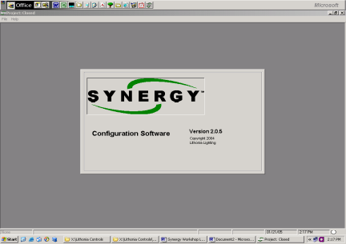

1.1  OPENING / CREATING / RETRIEVING A DATABASE |  | The first step in utilizing the Synergy Configuration Software (CONFIG.), to achieve the required lighting control, is to OPEN the CONFIG Program. Next, an existing database must be opened or retrieved, or a new database must be created.
1.2  THE  “PROJECT TAB” |  | Once the program and the specific database have been opened, the first “Tab” that is displayed is the “Project Tab”. This tab displays the basic information regarding the specific job / installation.
1.3  DEVICES |  | The next tab on the screen is the “Devices” tab. Devices are the controllers that are on the “S2” network. Each device should be given a name and the device’s control circuit phase must be set. Once all of the devices have been set up the remaining “Tabs” must have all of the appropriate information entered for each of the devices.
1.4  MODULES |  | There are 2 basis types of Power Modules that are installed in the lighting control panels. There are Relay and Dimmer Modules, which have specific addresses within their panel (Device).
1.5  RELAYS / DIMMERS |  | The next two tabs are the “Relay” and “Dimmer” tabs. Each relay should be given a name. The relay type must be set and the phase of the lighting load circuit that it is controlling must also be set.  Dimmers should also be named. Their curve must be set based on the type of lighting load they are controlling and typically their “high set” and “low set” points may be set up. Dimmers are designed and installed in such a manner that they set their own phase.
1.6  GROUPS |  | Once all of the relays and dimmers in all of the devices have been set up, lighting groups (GROUPS) must be created. A group consists of one or more relays, one or more dimmers, or of other Groups. Every controlled relay / dimmer must always be a member of a Group.
1.7  INPUTS / CONTROLS |  | After all of the Groups have been created they must be assigned / linked to an input(s). There are several types of inputs / control devices.
1.7.1 MANUAL –  SWITCHES &  STATIONS |  | There are low voltage switches (SWITCHES), Digital Stations (STATIONS). Each of these should be given a name and must have their type set and must be assigned / linked to a Group.
1.7.2 EXTERNAL  ANALOG  SENSORS |  | There are also Analog Sensors (ANALOGS) – photocells or occupancy sensors. Each of these should be given a name and must have their type set and must be assigned / linked to a Group.
1.8  SCHEDULES / SCHEDULE ASSIGN |  | Another form of an “input” / control “device” is a schedule. A schedule is designed to control one or more groups. A schedule consists of a series of “Events”, each of which must be assigned to a group.  Each schedule and event should be named.  Once a schedule has been built it must assigned to a day or days of the week or it can be designed to “run” on dates that have been set up as “default holidays” (i.e. statutory holidays).
1.9  DOWNLOADING THE DATABASE |  | After the entire database has been created / modified it must be downloaded to the lighting controllers. This can be achieved via a serial connection (usually with a laptop computer) or via a “BACnet” or network connection via a computer that is installed on the “S2” network.

SECTION 2
OPENING / CREATING / RETRIEVING
A DATABASE

The first step in using the Synergy Configuration Software (CONFIG) is to start the program. By double clicking the Synergy icon on your desktop the program opens. CONFIG can be set up to open on the current (most recently accessed) database automatically or wait for you to open another existing database or create and open a NEW database. Once the database is open you are ready to program.

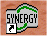

This section will cover:

- 2.1 OPENING AN EXISTING DATABASE

- 2.2 CREATING A NEW DATABASE

- 2.3 RETRIEVING AN EXISTING DATABASE:

  - 2.3.1 via A SERIAL CONNECTION
  - 2.3.2 via A COMPUTER ON THE “S2” NETWORK

2.1  OPENING AN EXISTING DATABASE |  | Once CONFIG has been opened, a specific database must be opened. CONFIG can be set up to automatically open the most recently accessed database by selecting:  - FILE….OPTIONS….OPEN LAST FILE  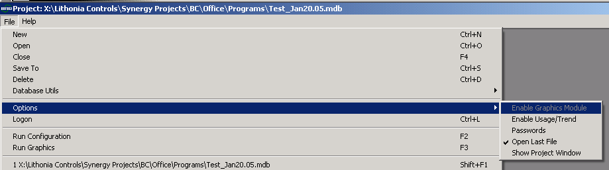  Every time you start CONFIG, the most recent database will now automatically open and you are set to start programming / modify the database.
2.1  OPENING AN EXISTING DATABASE (CONT) |  | If you want to open an existing database you must select:  - FILE….OPEN  The following window will open. Select the database that you want to open and click “OPEN”.  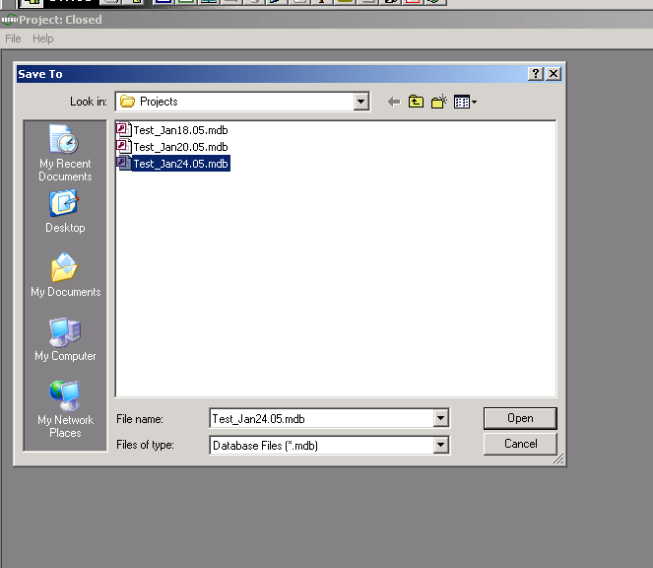  The selected project / database will open and the “Project Window” will appear. You are now set to start programming / modify the database.
2.2  CREATING A NEW DATABASE |  | If you are starting a new project you must open a new database by selecting:  - FILE….NEW  The following window will open. Enter the new project / file name in the “File name” box and click “OPEN”.  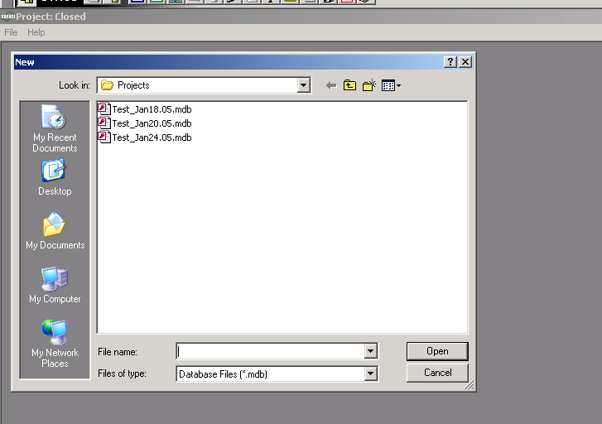  CONFIG will create and open the new project / database and the “Project Window” will appear. You are now set to start programming / modify the new database.
2.3  RETRIEVING AN EXISTING DATABASE FROM A NETWORK OF CONTROLLERS |  | Retrieving a database from a controller or network of controllers starts out by creating a NEW database, as above.  The database must be retrieved by one of the following methods:  - Via a serial connection between your computer (usually a laptop) and one of the serial ports located on the front of one of the “BRICKS”  - Via a computer (usually a PC) that is installed on the “S2” network via a network interface card or an Ethernet Router.
2.3.1  RETRIEVING AN EXISTING DATABASE FROM A NETWORK OF CONTROLLERS  VIA A SERIAL CONNECTION |  | After you have opened the new database and ensured that you serial cable is connected properly, you must perform the following. Your screen will appear as below. You must first (1) change the connection type to “Serial” by using the drop down arrow. Second (2) click the “Network Services Button” – The button in the upper left area of the screen that looks like a cluster of 5 computers. Synergy will search for all controllers on the “S2” network.  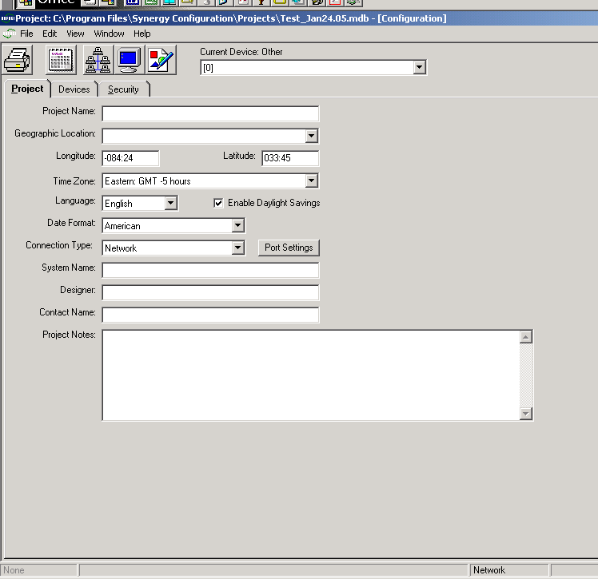
2.3.1  RETRIEVING AN EXISTING DATABASE FROM A NETWORK OF CONTROLLERS  VIA A SERIAL CONNECTION (CONT) |  | The following screen should appear:  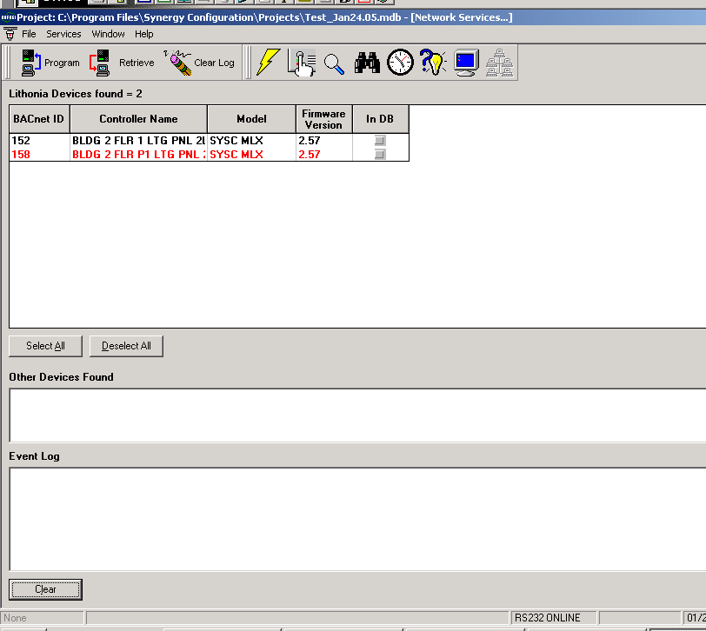  Click on the “Select All” button. All controllers will now be highlighted. Click the retrieve button. The following window will appear:  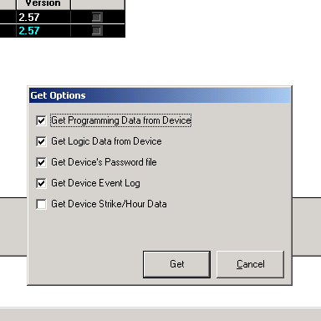 Click “Get”. You will get a warning message. Click “Yes” to overwrite the existing database, as this is a NEW database. The information will be retrieved from the controllers and stored in the database.  After the information has been retrieved, you can now close the “Network Services Window” by clicking on the lower “X” in the upper right corner of the screen. The “Project Window” will appear and you are now set to start programming / modify the database.
2.3.2  RETRIEVING AN EXISTING DATABASE FROM A NETWORK OF CONTROLLERS  VIA A NETWORK CONNECTION |  | The process for retrieving a database via a network connection is identical to retrieving via a serial connection with the exception of the type of “connection” that is chosen.  For “Connection Type” choose “Network” and then follow the steps as above.  After the information has been retrieved, you can now close the “Network Services Window” by clicking on the lower “X” in the upper right corner of the screen. The “Project Window” will appear and you are now set to start programming / modify the database.

SECTION 3
THE “PROJECT” TAB

The “Project Tab” displays all of the basic information regarding the specific project / database. It provides the following details:

- Project Name
- Geographic Location (Latitude & Longitude)
- Time Zone
- Language
- Date Format
- Connection Type
- System Name
- Designer
- Contact Name
- Project Notes

This section will cover:

- 3.1 CUSTOMIZING / ENTERING DATA ON THE “PROJECT TAB”

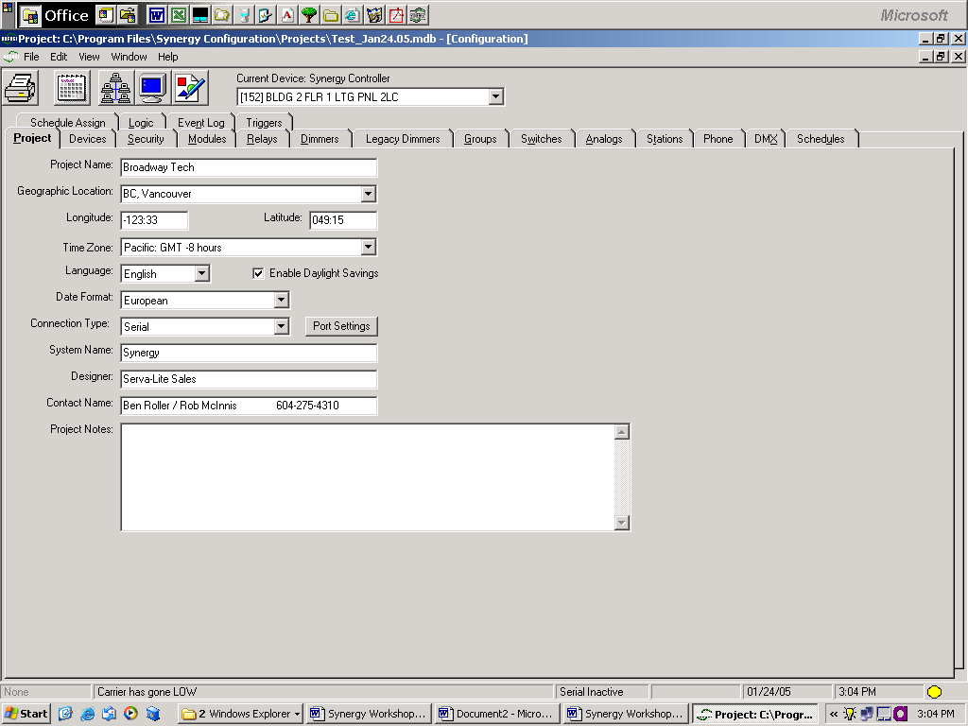

3.1  CUSTOMIZING / ENTERING DATA ON THE  “PROJECT TAB” |  | The “Project Name” is entered in the first box. Usually this is the name of the building or the site.  The “Geographic Location” is the next box. By clicking on the drop down arrow several cities / metropolitan areas throughout North America are displayed. One of these can be chosen or any city / town…can be entered here. If one of the listed cities is chosen the geographic coordinates and time zone are automatically entered. If a city is entered manually the coordinates and time zone must also be entered manually.  The “Language” drop down menu is used to select the language that will be displayed on the controller(s) face. English, French, or Spanish can be chosen.  The “Date Format” to be displayed on the controllers can be selected from the drop down menu:  - American: MM / DD / YY  - European: DD / MM / YY  The “Connection Type”, as mentioned in Section 2, is used to select the type of communication connection through which your computer will be connected to the controllers / “S2” network.  The “System Name” is generally entered as “Synergy”, however, anything “custom” can be entered here.  “Designer” and “Contact Name” are usually the name of the company that created / designed the database and the contact person / telephone number / e-mail address, etc.  The “Project Notes” box is used to enter any pertinent information that future personnel accessing the database may be required to be aware of.

SECTION 4
DEVICES

A Synergy System consists of a single controller or a network of controllers on the “S2” network. The “Devices” tab is where the controllers are set up within the CONFIG program.

This section will cover:

- 4.1 ADDING AND NAMING A NEW DEVICE

- 4.2 PHASING THE NEW DEVICE

4.1  ADDING AND NAMING A NEW DEVICE |  | To add a new device / controller to the network, right click anywhere on the blank area of the “Devices” page and select “Add Device”  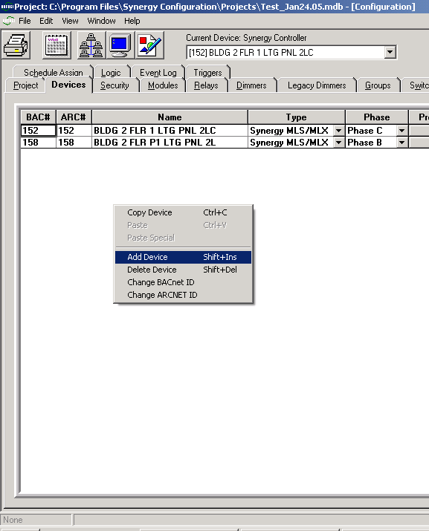
4.1  ADDING AND NAMING A NEW DEVICE (CONT) |  | The following window will appear:  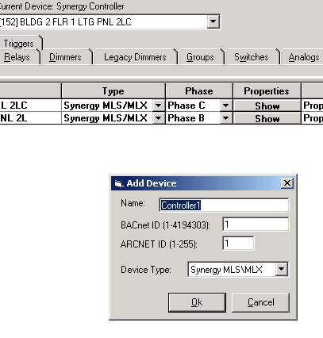  Enter the “Name” of the device. This is usually the physical location of the controller / panel (i.e. “Electrical Room 101”) and or the breaker panel that is feeding it (i.e. “Panel 2LC”).  Enter the “BACnet ID” and “ARCNET ID”. These numbers are the “address” of the associated device and are unique to ONE device on the network. The two ID’s are typically the same number, however, they do not have to be the same. Select “Device Type” from the drop down menu. This will generally be the default “Synergy MLS\MLX”.  Click “OK”.  The new device will appear in the list of devices.
4.2  PHASING THE NEW DEVICE |  | Once all of the devices have been added, the phase must be set. This is the phase (A / B / C) of the electrical circuit that is feeding the power supply for the associated device. The electrical contractor that installed the equipment usually provides this information. Choose the correct phase from the drop down menu:  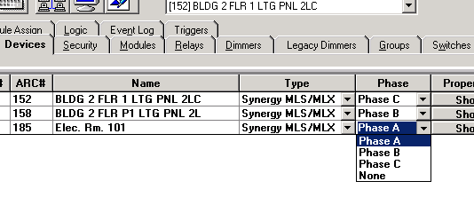

SECTION 5
MODULES

Power modules (Relays and/or Dimmers) must now be added to each of the devices that have been “created” in the database. Starting with this “tab” (Modules) and proceeding with the remaining tabs (i.e. “Relays”, “Dimmers”, “Groups”, etc…), you must first select the device that you will be programming. You must select the appropriate device from the “Current Device” drop down menu as shown below:

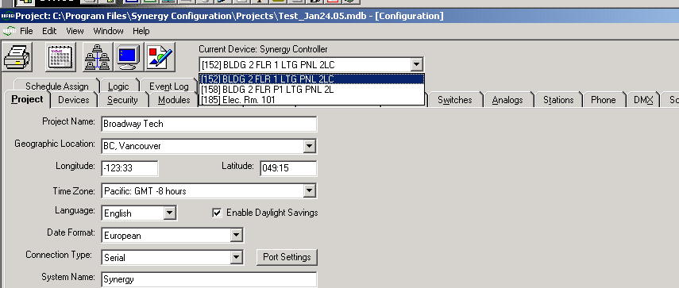

This section will cover:

- 5.1 ADDING A NEW MODULE

5.1  ADDING A NEW MODULE |  |  | Once you have selected the device to which you will be adding modules, you must click on the “Modules” tab and select the module type(s) that you are adding.  Each module has a unique address within the device (panel) of which it has been installed. There is an address wheel / switch on each power module that is typically set by the installer / electrician. See below:  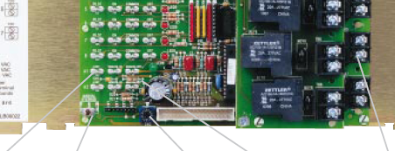  ADDRESS WHEEL / SWITCH
5.1  ADDING A NEW MODULE (CoNT) |  |  | The “Modules” tab has two columns labeled “Address” and “Dial Pos” respectively. The “Dial Pos” is the number that the corresponding module’s address wheel has been set at. As it implies, this “Dial Pos” is also the “Address” of that module. You must now add in all of the modules associated with the current device by selecting the type from the drop down menu under the “Module Type” column:  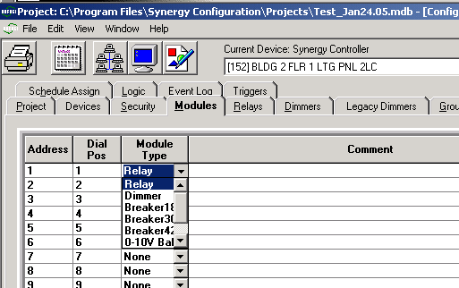  Select the module type and it will be added. Proceed to the next “Address” and add the proper module in the same manner.  After you have added all of the modules for the current device, select the next device and add all of its required modules.
SECTION 6
RELAYS AND DIMMERS

Each of the relay modules consists of 8 relays and each dimmer module consists of 6 dimmers. As indicated above, you must first select the device from the “Current Device” drop down menu and then click on the “Relay” or “Dimmer” tab, depending on which type of module that you are programming. Each relay / dimmer has a unique address within its own module. The first 2 digits of the relay number / dimmer number (as shown in the “Number” column) are the module number as programmed on the “Modules” tab. The next 2 digits are the number of the specific relay / dimmer on each module. See below:

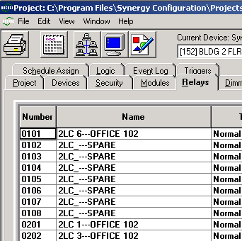

This section will cover:

- 6.1 NAMING OF RELAYS

- 6.2 SETTING OF RELAY TYPE & PHASING OF RELAYS

- 6.3 NAMING OF DIMMERS

- 6.4 SETTING OF DIMMER CURVE

- 6.5 SETTING OF DIMMER “HIGH SET” & “LOW sET”

6.1  naming of relays |  |  |  |  | The first step in programming relays is naming them. This is not necessary for the system to function, but is STRONGLY recommended.  Each relay’s name will default to its associated number / address (i.e. a relay with the number 0301 will have the name “Relay 301”). This name should be changed to reflect the lighting load that it is controlling.  For example:  Relay 205 is fed from electrical panel number 2LC and circuit breaker number 14. The lighting load that it is controlling is in Office # 457 in a tenant named “Smith Engineering”. An appropriate name for this relay would be:  “2LC_14 - Smith Engineering – Office 457”  This information must now be entered in the appropriate “Name” box on the relay tab. Double click on the “Name” box and back space over the existing data:  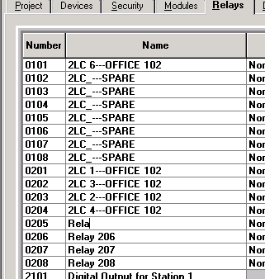  Then, enter new data:  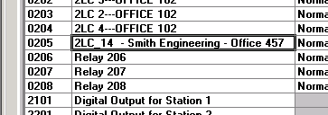
6.2  setting of relay type and phasing of relay |  |  |  |  | Next, each relay type must be set and the electrical phase that it is controlling must also be set.  There are several types of relays, with “Normal” being the most common type. A normal relay’s contacts will close, completing the circuit to the lighting load, when it receives an “On Command” and vice versa. An “Inverted” relay performs the reverse action (i.e. contacts close when it receives an “Off Command”.  Select the relay type from the drop down menu:  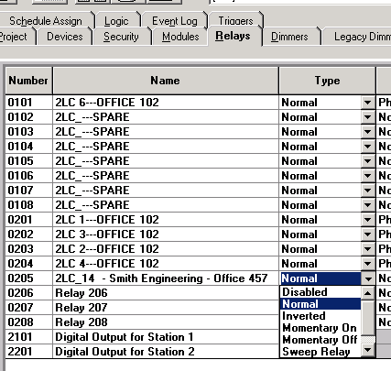
6.2  setting of relay type and phasing of relay (cont) |  |  |  |  | Next, each relay’s phase must be set. The information regarding the electrical circuit that is controlled by each relay is usually provided by the electrician.  Select the relay phase from the drop down menu:  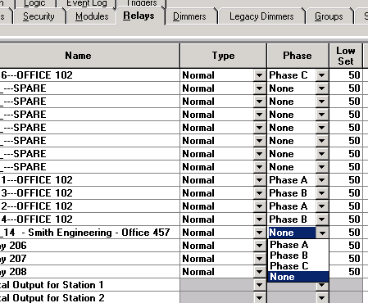  Once all of the relays have been named, had type set, and phase set, proceed to the next device.
6.3  naming of dimmers |  |  |  |  | Dimmers are named in the same manner as relays:  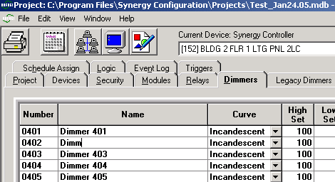  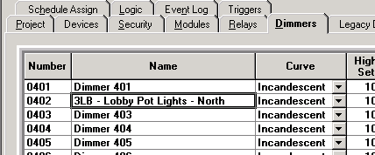  Each dimmer module within a device is fed by a single electrical circuit. Therefore ALL six dimmers on that module are controlling the same phase and the electronic circuitry on the module determines the correct phasing. Phase does not need to be set by the programmer.
6.4  setting of dimmer curve |  |  |  |  | Each dimmer must have its “Dimmer Curve” set. The “Dimmer Curve” varies depending on the type of lighting load that is being controlled. A lighting load can consist of incandescent lighting (tungsten / halogen…) or it can be dimmable fluorescent ballasts.  You must choose the correct curve from the drop down menu:  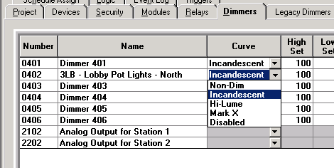
6.5  setting of dimmer “high set” & “low set” |  |  |  |  | Each dimmer’s “High Set” and “Low Set” points can be entered. These are entered as a percentage (i.e. a value from 0 – 100). A dimmer’s “High Set” point determines the maximum output voltage of that dimmer. The “Low Set” determines the minimum output voltage.  For example, if a dimmer is controlling a 120 Volt circuit and its “High Set” is set to 80 and its “Low Set” to 20, the maximum output voltage of the dimmer would be (80% of 120 – which is 96 volts). Its “Low Set” would be (20% of 120 – which is 24 volts). When the dimmer is commanded to dim any lower than this level, it shuts off the connected lighting load.  To set these levels, double click on either the “High Set” or “Low Set” box and adjust by clicking the up and down arrows:  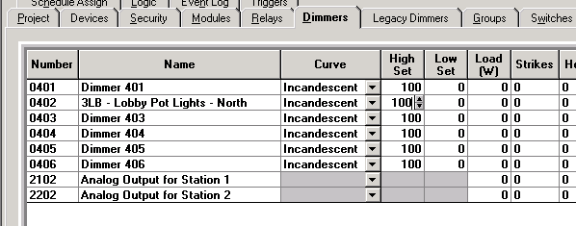  Once all of the dimmers have been named, had curve set, and “High” and “Low” set, proceed to the next device.
SECTION 7
GROUPS

Now, with all of the outputs (relays and or dimmers) programmed, lighting groups (Groups) must be created. As mentioned above, a group consists of one or more relays, one or more dimmers, or of other Groups. Any of these “parts” of a Group are referred to as “Group Members”. Every controlled relay / dimmer must always be a member of a Group. When the database is first created a number of default Groups are created. These may be modified to contain any required “Group Members” or new Groups can be created. The new Groups can then have their “Group Members” entered. Groups are created to contain members (lighting loads) that are typically controlled by the action of an input device (i.e. when the input device (e.g. a switch) is activated ALL members of the Group will respond).

This section will cover:

- 7.1 CREATING (ADDING) GROUPS

- 7.2 RENAMING A GROUP

- 7.3 EDITING GROUP MEMBERS

  - 7.3.1 ADDING RELAYS AND DIMMERS TO A GROUP
  - 7.3.2 ADDING OTHER GROUPS TO A GROUP

7.1  CREATING (ADDING) GROUPS |  |  |  |  |  |  | To add a Group, click on the Group tab. This tab is split into two sections (Groups and Members). Right click on the Groups section and the following menu will appear:  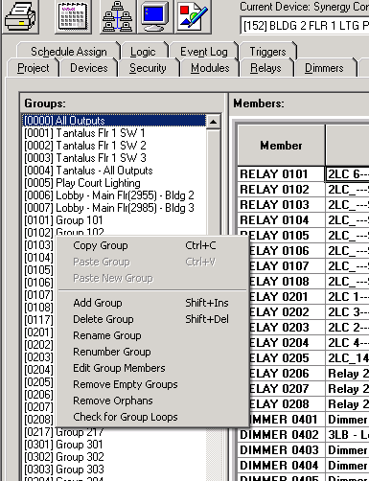
7.1  CREATING (ADDING) GROUPS (CONT) |  |  |  |  |  |  | Select “Add Group” and a new Group will appear at the bottom of the existing list of Groups:  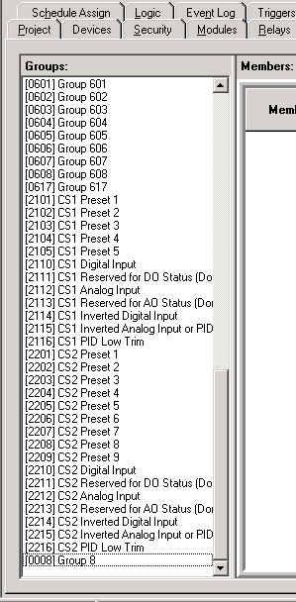
7.2  renaming a group |  |  |  |  |  |  | Once all of the Groups have been added they should be renamed to reflect the area / zone of the building that its Group Members are controlling.  For example, an office building may have some lighting controlled by several relays in a specific tenant’s boardroom.  To rename a Group, click on the selected Group in the list so that it is highlighted. Right click and the following window will open:  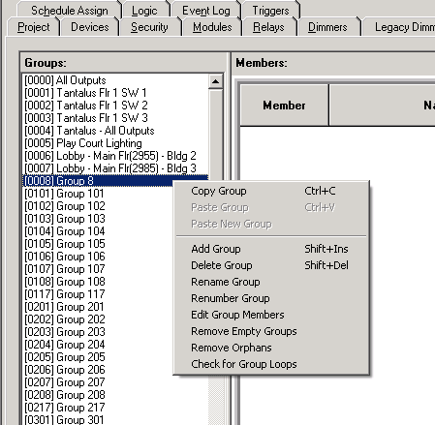  Select “Rename Group” and the following window will appear:  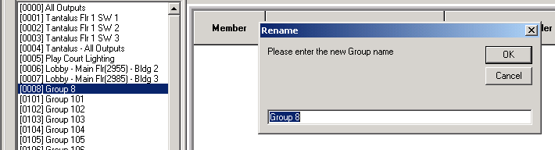  Enter the new Group name. For this example you may enter “Smith Engineering Boardroom”. Click OK.  Continue until all Groups in all of the devices have been renamed.
7.3  editing group members |  |  |  |  |  |  | Once all of the Groups have been named, members must be added to each Group. This is referred to as “Editing Group Members”. To edit a Group, click on it so it is highlighted. Next double click on the Group or right click on the Group:  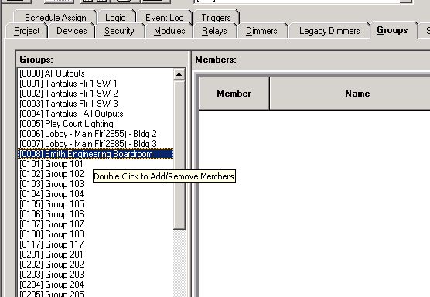  If you right click the following menu will open:  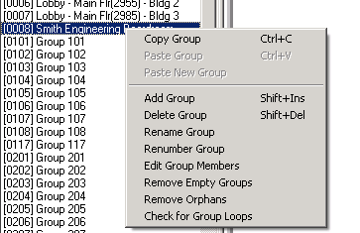  Select “Edit Group Members”.
7.3.1  adding relays and dimmers to a group |  |  |  |  |  |  | Whether you double clicked on the selected Group or right clicked and selected “Edit Group Members”, the following window will open:  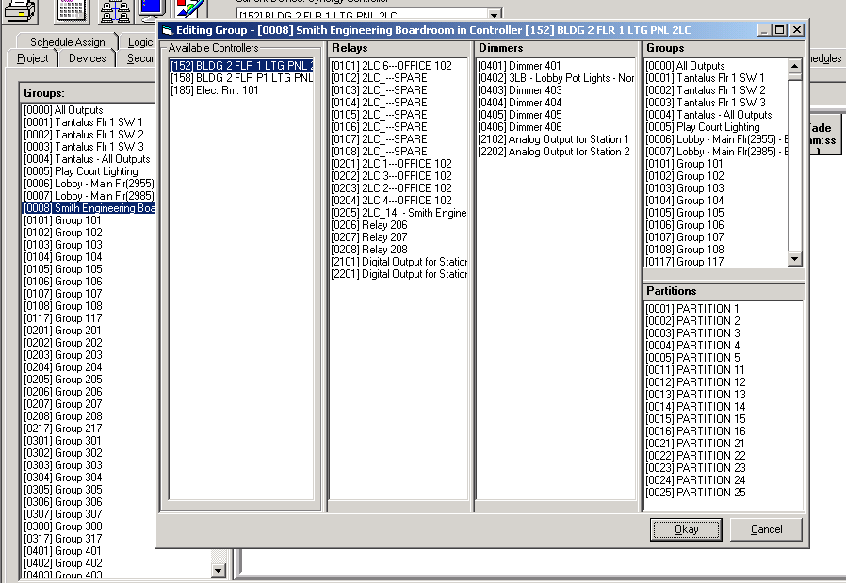  First, select from the “Available Controllers” column the controller / Device from which you want to add members (Relays / Dimmers). It is not necessary, but it is STRONGLY recommended, that if you want to add relays / dimmers that are installed in ANOTHER controller (Device) to the Group that is in the Current Device, that you first create a Group of those members in their “own” controller (Device). That “sub” Group can then be made a member of the Current Device’s Group (see next section 7.3.2 Adding other Groups to a Group).  To add relays / dimmers to a Group, select them from the Relay / Dimmer column. Once selected the relay / dimmer will turn red. When you have selected all of the members, click OK.
7.3.2  adding other groups to a group |  |  |  |  |  |  | To add other Groups to the current Group that is being edited, select the Group from the Group column. If Groups from other controllers are to be added, first select the controller from the Available Controllers column.
 |  |  |  |  |  |  | Once all of the Groups in all of the controllers have been created, named, and edited they must be “assigned” to an input / control device.
SECTION 8
INPUTS / CONTROLS

After all of the Groups have been created they must be assigned / linked to an input(s). There are several types of inputs / control devices:

- Low Voltage Switches – “SWITCHES”
- Digital Stations – “STATIONS”
- Analog Sensors (Photocell & Occupancy Sensors) – “ANALOGS”

Each of these inputs should be named and must have their type set and must be linked / assigned to a Group. An input can have only one Group assigned to it; however, any Group can be assigned to multiple inputs.

This section will cover:

- 8.1 NAMING OF SWITCHES

- 8.2 SETTING OF SWITCH TYPE

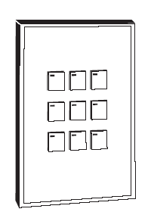
- 8.3 ASSIGNING A GROUP TO A SWITCH

- 8.4 ADDING A STATION

- 8.5 NAMING OF STATIONS

- 8.6 NAMING OF STATION BUTTONS

- 8.7 SETTING OF BUTTON TYPE

- 8.8 ASSIGNING A GROUP TO A BUTTON

- 8.9 NAMING OF AN ANALOG SENSOR

- 8.10 SETTING OF AN ANALOG SENSOR TYPE

- 8.11 ASSIGNING A GROUP TO AN ANALOG SENSOR

8.1  naming of switches |  |  |  |  |  |  |  | There are various types of low voltage switches. Regardless of the type, the wiring from the Switch is landed at one of the sets of switch input terminals located on the power modules (Relays / Dimmers). The first two digits in the number of the Switch are the address of the module of which it is part. The next two digits are the set / row of Switch Input Terminals on that module (i.e. the switch number for the third row of terminals on Module number 4 is: 0403). The method of naming Switches is the same as naming Relays.  Once you have selected the Switch tab, double click on the “Name” box of the appropriate Switch and back space over the existing data:  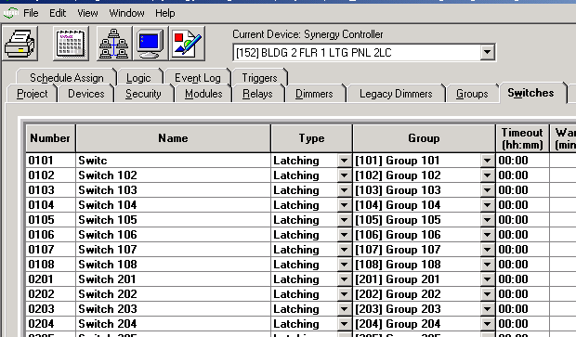  Then, enter new data. Typically a Switch is named with its physical location within the building (e.g. “Second Floor Reception”) or with the Group that it is controlling:  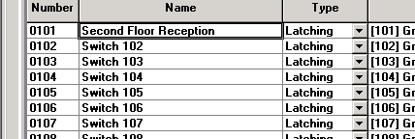
8.2  Setting of switch type |  |  |  |  |  |  |  | There are several types of Switches. The required “Type” for each switch must be selected from the drop down menu. Some examples of switch types are:  - Latching: This type of switch action would cause the assigned Group to turn on and remain on even if the switch were pressed again.  - Alternate: This type of switch action would cause the assigned Group to turn on. Pressing the same switch again would cause the Group to turn off.  - Maintained: This type of switch action would cause the assigned Group to turn on and remain on as long as the switch is held.  - Ramping: This type of switch action is used in dimming applications.  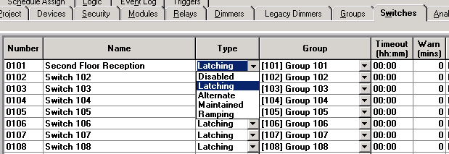
8.3  assigning a group to a switch |  |  |  |  |  |  |  | Each Switch must have a specific Group assigned to it. The Group that is assigned to the Switch will react to the input action. The Group is selected from the drop down menu:  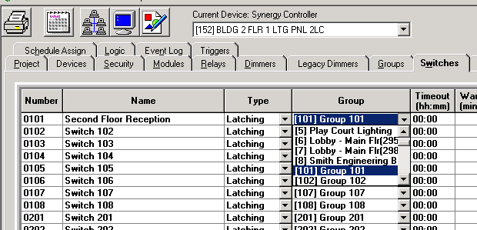
8.4  adding a station |  |  |  |  |  |  |  | Digital Stations (Stations) are physically connected in a “Daisy Chain” fashion on the “A4” network, which is landed directly to the “BRICK” (Controller). Each controller may have an “A4” network. The Stations communicate to the “BRICK” via a digital signal over this network. All stations that are installed on each “A4” network must be “Added” to the database via programming. Each Station has a unique address, which is set on the Station via its address wheel similar to the Module’s address wheel.  A Station is added as follows:  On the Station tab, select the drop down menu, pertaining to the appropriate Station address, under the “Type” heading:  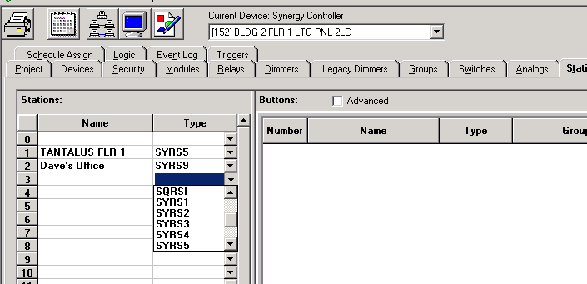  Select the appropriate station type (i.e. an “SYRS 3” is a Digital Station with three buttons).
8.5  naming a station |  |  |  |  |  |  |  | The method of naming Stations is the same as naming Relays and Switches. Double click on the “Name” box of the appropriate Station and back space over the existing data:  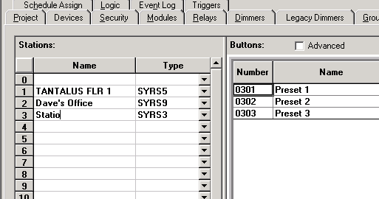
8.5  naming a station (cont) |  |  |  |  |  |  |  | Then, enter new data. Typically a Station is named with its physical location within the building (e.g. “Third Floor East Wall”):  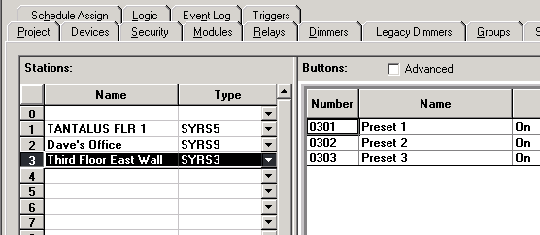
8.6  naming of station buttons |  |  |  |  |  |  |  | Each button on the Station should now be named. In the “Button” section of the Station tab double click on the “Name” box of the appropriate Button and back space over the existing data:  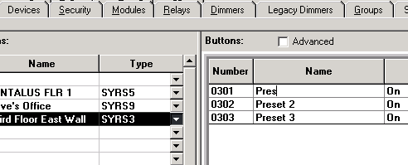  Then, enter the new data. Typically a Button is named with the Group that it is controlling:  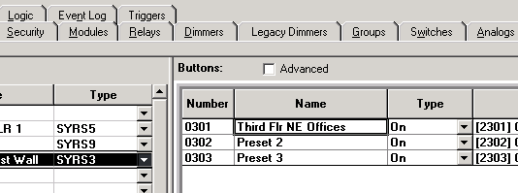
8.7  setting of button type |  |  |  |  |  |  |  | Button types are similar to Switch types. Select the appropriate button type from the drop down menu:  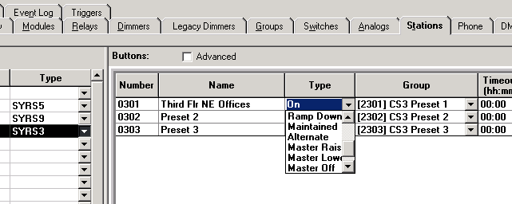
8.8  assigning a group to a button |  |  |  |  |  |  |  | Each Button must have a specific Group assigned to it. The Group that is assigned to the Button will react to the input action. The Group is selected from the drop down menu:  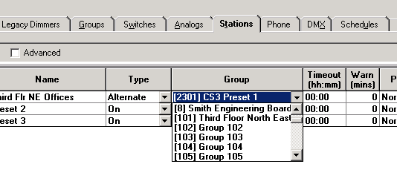
8.9  naming of an analog sensor |  |  |  |  |  |  |  | Another type of input device is an Analog Sensor. These can be photocells or occupancy sensors.  First, select the Analogs tab. The first two digits in the number of the Analog device are the address of the module of which it is part. The next two digits are the set / row of Analog Input Terminals on that module (i.e. the Analog device number for the lower row of terminals on Module number 4 is: 0402).  The method of naming Analog devices is the same as naming Relays. Double click on the “Name” box of the appropriate Analog device and back space over the existing data:  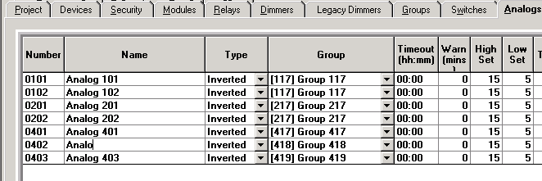  Enter the new data:  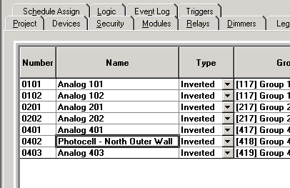
8.10  setting of analog sensor type |  |  |  |  |  |  |  | The type of Analog sensor must now be set. A typical photocell will be set as an “Inverted” type. A photocell will react to an increase in natural light by turning on. When a photocell turns on, typically it will cause lighting to turn off. Therefore it is referred to as an “Inverted” input. Select the Analog Type from the drop down menu:  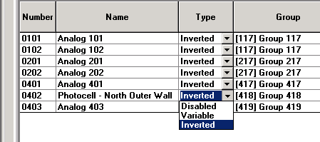
8.11  assigning a group to an analog sensor |  |  |  |  |  |  |  | Each Analog device must have a specific Group assigned to it. The Group that is assigned to the Analog device will react to the input action. The Group is selected from the drop down menu:  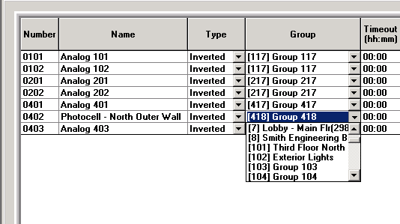
SECTION 9
SCHEDULES AND SCHEDULE ASSIGN

A schedule consists of a series of “EVENTS”. Events are actions that are programmed to cause the appropriate group to respond at a specific assigned time.

Specific times can be programmed for each “EVENT” to occur, or as in the case of controlling exterior lighting, the Synergy system has a built-in internal “Astronomical Time Clock” that recognizes when dawn and dusk occur every day, based on your particular geographical location.

Once a daily schedule has been created it must be assigned to a day or days of the week. Typically a schedule will be assigned to Mon. – Fri., and another schedule to Sat. – Sun. Specific schedules can also be designed for “holiday” days, such as statutory holidays or extended periods where the building will not be operating on a typical workday schedule.

Schedules can be designed to be quite general or very specific.

A typical schedule of an office building would consist of common area lighting programmed to turn on at a pre-determined time in the morning and to turn off in the late afternoon / early evening (depending on the typical workday hours of the tenants).

In order to save energy, the tenants would usually turn on individual tenant area lighting manually, as they occupy their office space. The “OFF EVENT” for tenant areas would be programmed in the system to turn off at a pre-determined time. Working with the various tenants, you would determine their typical hours of operation and design the schedule to accommodate their needs.

“SWEEP” events are typically programmed to occur every hour or two at times when a building is usually unoccupied. The system “sweeps” the entire building and turns off lights that have been left on.

The schedule of “EVENTS” programmed for exterior lighting is usually designed to work with the “Astronomical Time Clock” and not by specific times entered by the user. However, any method of scheduling can be used for any area of lighting.

This section will cover:

- 9.1 CREATING (ADDING) A SCHEDULE

- 9.2 NAMING OF A SCHEDULE

- 9.3 MODIFYING A SCHEDULE

  - 9.3.1 ADDING AND NAMING TIME EVENTS
  - 9.3.2 ADDING AND NAMING DAWN / DUSK EVENTS
  - 9.3.3 SETTING A WARN TIME
  - 9.3.4 setting the lighting level
  - 9.3.5 ASSIGNING OF A GROUP TO AN EVENT

- 9.4 ASSIGNING A SCHEDULE TO DAYS OF THE WEEK

9.1  CREATING (ADDING) A SCHEDULE |  |  |  |  |  |  |  | The Schedules tab is split into three section:  - Schedules  - Events  - Dusk / Dawn Events  To add a new Schedule, right click on the “Schedule” section and the following menu will open:  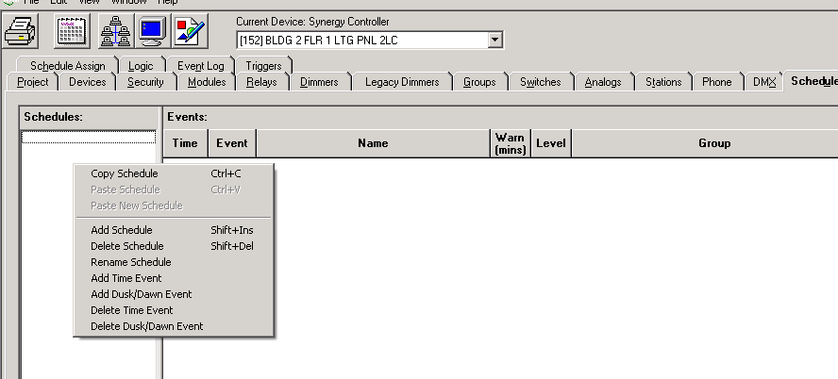  Select “Add Schedule” and a new schedule will appear under the Schedules heading:  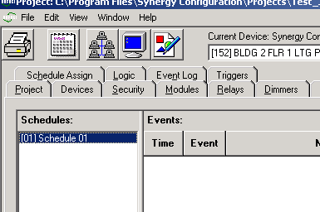
9.2  namING of A SCHEDULE |  |  |  |  |  |  |  | To name / rename a Schedule right click on the highlighted Schedule and select “Rename Schedule” from the menu:  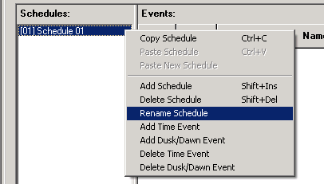
9.2  namING of A SCHEDULE (cont) |  |  |  |  |  |  |  | The following window will open:  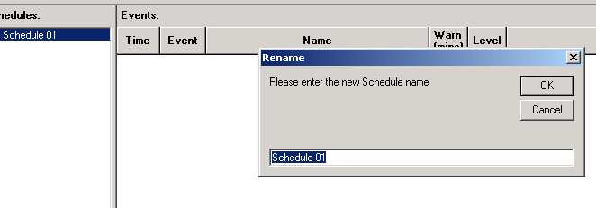  Enter the new Schedule name. Typically a schedule will be named with the day(s) of the week to which it is assigned or with the building name it is controlling.
9.3  modifyING A SCHEDULE |  |  |  |  |  |  |  | Modifying a Schedule consists of adding timed events and adding dawn and dusk events. Warning times are set for each event. Each event must be assigned to a specific Group.
9.3.1  adding and naming time events |  |  |  |  |  |  |  | Time Events are added to a schedule by right clicking in the “Events” section on the Schedules tab. The following menu will appear:  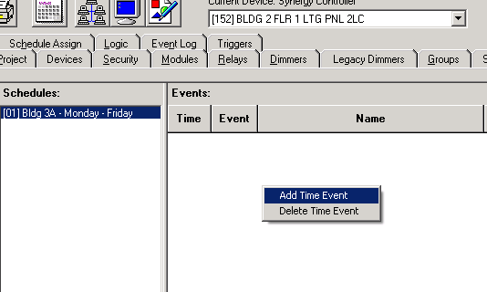  Select “Add Time Event”. A new Event will appear in the Events section:  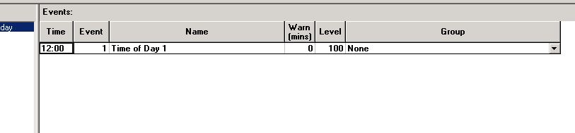
9.3.1  adding and naming time events (Cont) |  |  |  |  |  |  |  | Double click on the time that is in the box under the “Time” heading and use the up and down arrows to adjust the hours and minutes to the time that you want the event to occur. The clock is in 24 hour format:  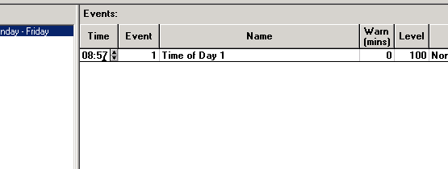  Next, double click on the “Name” box of the event and name the event in the same manner as naming Relays, Switches, Stations, etc.:  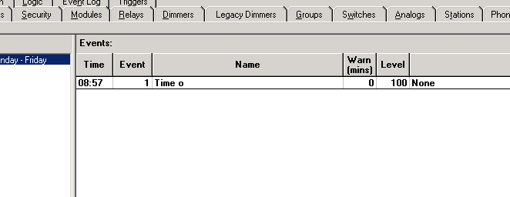  Typically an event’s name will consist of the area of lighting that it is controlling and the action that is happening at that time (e.g. Lobby Lights are to turn on at 8:57 A.M.). Therefore the Event Name would be: “Lobby Lights – On – 8:57 A.M.):  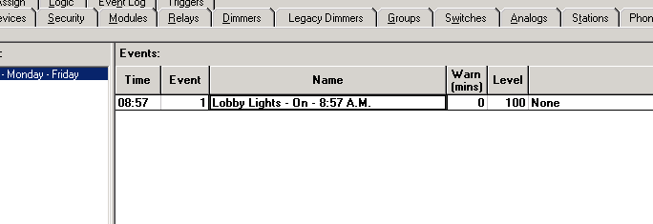
9.3.2  adding and naming dawn / dusk events |  |  |  |  |  |  |  | Dusk and Dawn Events are added and named in the same manner as Time Events. Right click in the “Dusk / Dawn Events” section and select “Add Dusk / Dawn Event” from the menu. A new Dusk / Dawn Event will appear in this section:  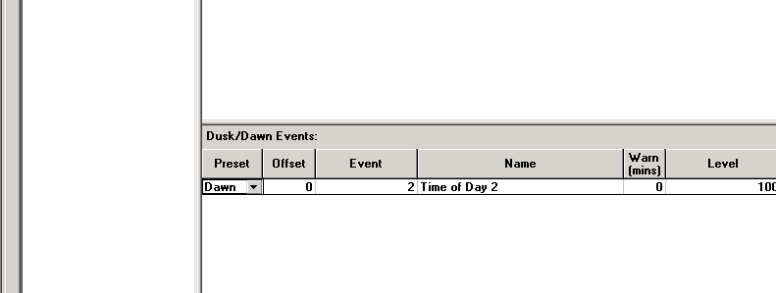  Click on the drop down menu in the “Preset” column and choose if the Event is to occur at Dusk or Dawn.  Then double click on the number in the “Offset” box. The Offset is used to cause the event to occur prior to or after Dawn or Dusk. For example, if it is required to turn on exterior lighting 30 minutes before dusk, adjust the Offset to –30:  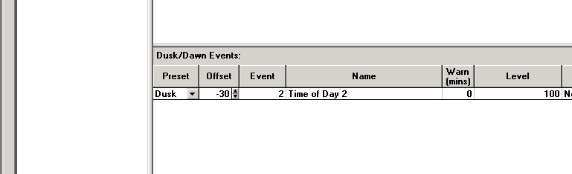  Next, name the event in the same manner as a Time Event:  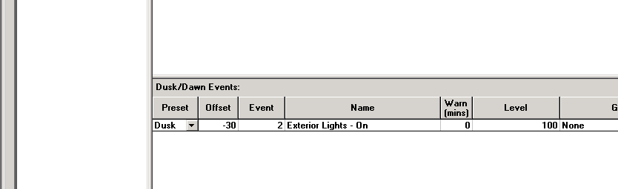
9.3.3  Setting a warn time |  |  |  |  |  |  |  | Typically a Warn Time is set for “Off” events only. A typical Warn Time is 5 minutes. Double click on the number in the Warn box for the appropriate Event and use the up and down arrows to adjust the Warn Time:  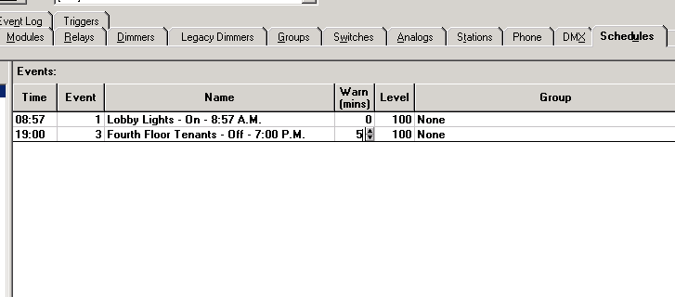  With the Warn Time set, the assigned Group of lights will briefly flash at, in this example, 5 minutes prior to the scheduled off time. This warns the building occupants that lighting in their area will be turning off shortly.
9.3.4  Setting the lighting level |  |  |  |  |  |  |  | Next, the lighting level must be set. This is the level at which the assigned Group be set to at the Event time (i.e. a Level of 100 is “On” and a Level of 0 is “Off”). If dimmers are being controlled, any value between 0 and 100 can be entered here, and the Group of assigned dimmers will be set to that lighting level at the Event time.  Double click on the number in the Level box for the appropriate Event and adjust the value with the up and down arrows:  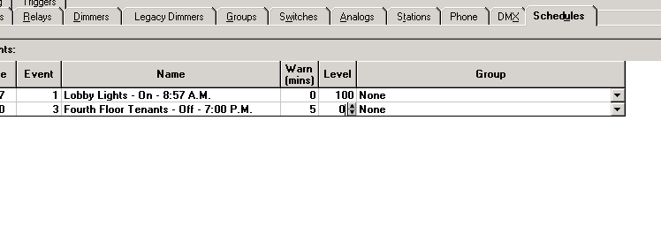
9.3.5  assigning of a group to an event |  |  |  |  |  |  |  | Each Event must have a Group assigned to it. Click on the drop down menu in the Group box and select the appropriate Group:  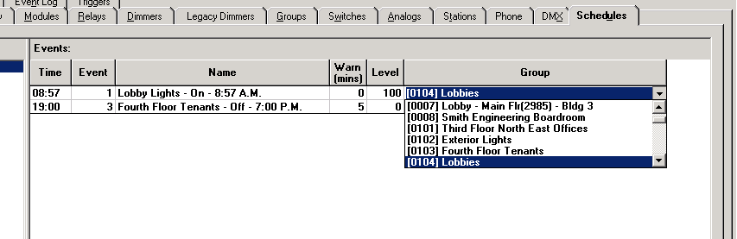
9.4  assigning a schedule to days of the week |  |  |  |  |  |  |  | When all the schedules have been created, they must be assigned to the day(s) of the week on which the schedule is to “run”. Select the “Schedule Assign” tab. From the drop down menu, select a schedule that will run on each day of the week:  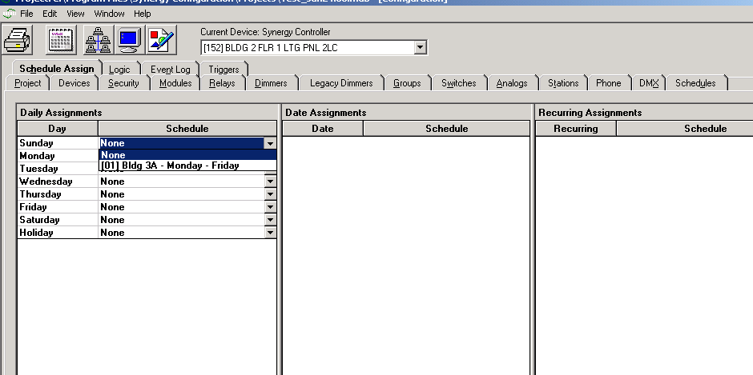
9.4  assigning a schedule to days of the week (cont) |  |  |  |  |  |  |  | Specific Date and Recurring Date Assignments can be set up on this tab. These dates are usually holidays or “down” times for the building. These dates will usually have a custom schedule designed for them and run the “Default Holiday” schedule. Recurring Dates are set up as shown below. Right click in the appropriate area on the Schedule Assign tab and select “Add Date”. A calendar will appear. Select the required date by clicking on it. Date Assignment is for One Time, only. Recurring Dates, once set up, recur every year on the assigned date:  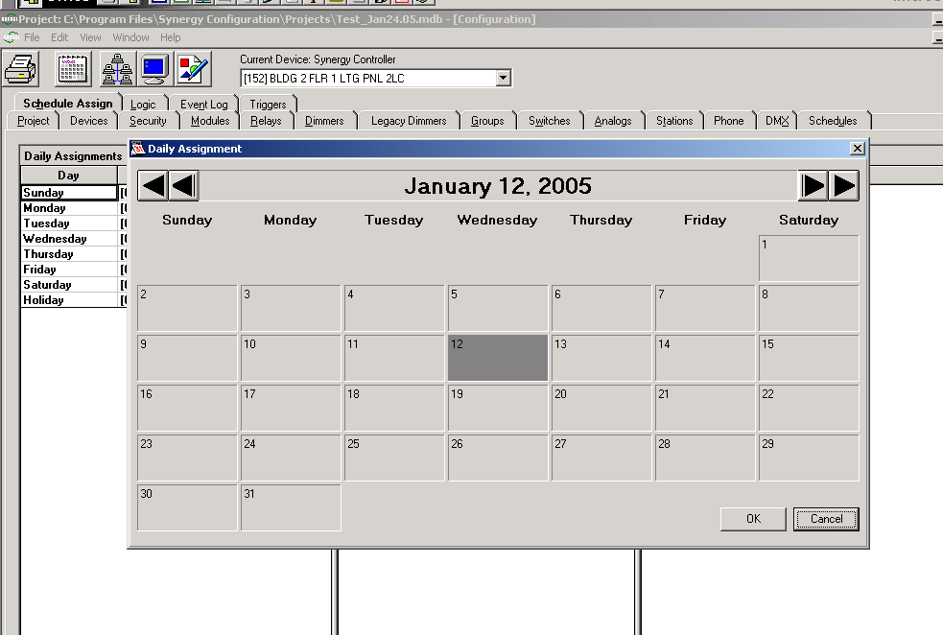  Click OK. Choose the schedule for the date from the drop down menu. This usually remains as the “Default Holiday”:  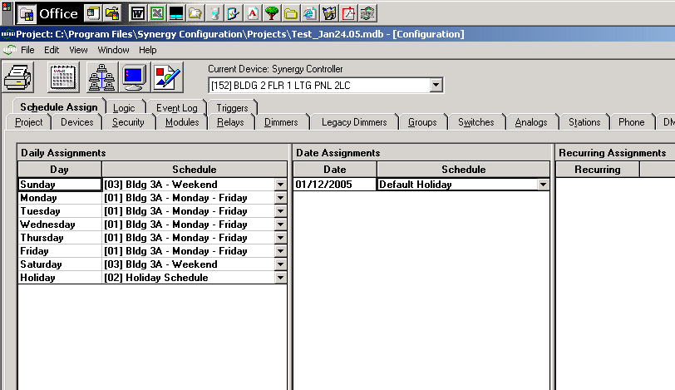

SECTION 10
DOWNLOADING (PROGRAMMING) THE LIGHTING CONTROL PANELS

Downloading the database to the lighting controllers is similar to retrieving the existing database from the controllers. This can be achieved by a serial connection or by a network connection.

This section will cover:

- 10.1 downloading program via a laptop computer with a serial connection

- 10.2 downloading program via a pc which is installed on the “S2” network

10.1  downloading program via a serial connection |  | After you have programmed the new database and ensured that you serial cable is connected properly, you must perform the following. Your screen will appear as below. You must first (1) change the connection type to “Serial” by using the drop down arrow. Second (2) click the “Network Services Button” – The button in the upper left area of the screen that looks like a cluster of 5 computers. Synergy will search for all controllers on the “S2” network.  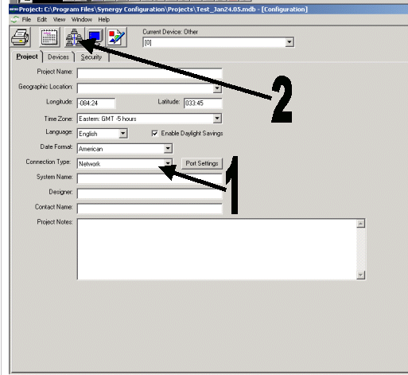
10.1  downloading program via a serial connection  (cont) |  | The following screen should appear:  Click on the “Select All” button. All controllers will now be highlighted. Click the Program button. The following window will appear:  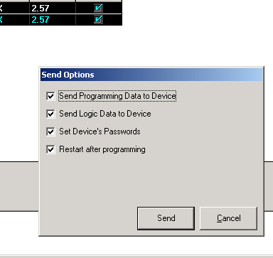
10.1  downloading program via a serial connection  (cont) |  | Click “Send”. You will get a warning message. Click “Yes” to overwrite the existing database, as this is a NEW database. The information will be sent to the controllers.  After the information has been sent, you will see the following message:  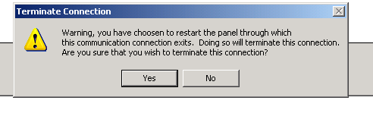  Click “Yes”  The following will appear:  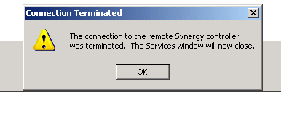  Click “OK”  The “Network Services Window” will close and the “Project Window” will appear. The lighting control panels have been programmed and you can now close “Synergy Config”.
10.2  downloading program via a network connection |  | The process for programming a database via a network connection is identical to programming via a serial connection with the exception of the type of “connection” that is chosen.  For “Connection Type” choose “Network” and then follow the steps as above.  After the control panels have been programmed, you can now close the “Network Services Window” by clicking on the lower “X” in the upper right corner of the screen. The “Project Window” will appear. The lighting control panels have been programmed and you can now close “Synergy Config”.

